EASTERN AFRICA STATISTICAL TRAINING CENTRE
DSU07210 — Linux Systems Administration
Group Assignment Submission Template
Data Science Year 1 | Academic Year 2025/2026

A. Group & Assignment Information

Group & Assignment Details
Assignment No. | 02 | Session | C
Assignment Title | Linux Systems Administration
Group No. | 10 | Date Submitted | 7th June 2026
Academic Year
2025 / 2026

B. Group Members
List all group members. The Role/Task column should show which task(s) each member led.

# | Full Name | Reg. Number | Session | Role / Task
1 | FREDY RESPICHIUS MATUNGWA | EASTC/BDTS/26/04195 | 10 C | Group organizer,led task 1
2 | TEKLA JOHN MKUDE | EASTC/BDTS/25/02469 | 10 C | Led task 4 and creativity idea
3 | MARIA AGUSTINO KIKOTI | EASTC/BDTS/26/04694 | 10 C | Led task 5 and code verfied
4 | GLORY PETER SALUM | EASTC/BDTS/26/04583 | 10 C | Led task 3 and creativity idea
5 | KELVIN EMANUEL SILVESTA | EASTC/BDTS/26/01903 | 10 C | Led task 2 and screenshots
6

C. Assignment Instructions Summary
Before starting, re-read the full assignment from your lecturer. Then tick the boxes below as you complete each task.

- Every command must be run on a real Linux terminal.
- Screenshots or terminal recordings are required as evidence.
- Complete the Creativity Challenge with a scenario your group designs.
- Each member completes the Self-Exploration section individually.
- Submit this template as your group report (printed or PDF).

D. Task Completion Checklist
For each task: briefly describe what your group did, mark whether it is complete, and note the evidence (e.g. screenshot filename or page number in your terminal log).

# | Task Description (summarise what you did) | Done? (Yes/No) | Evidence
1 | We firstly create a text file name Hobbies tha consist of exactly 30 line of content about cryptocurrency | Yes | 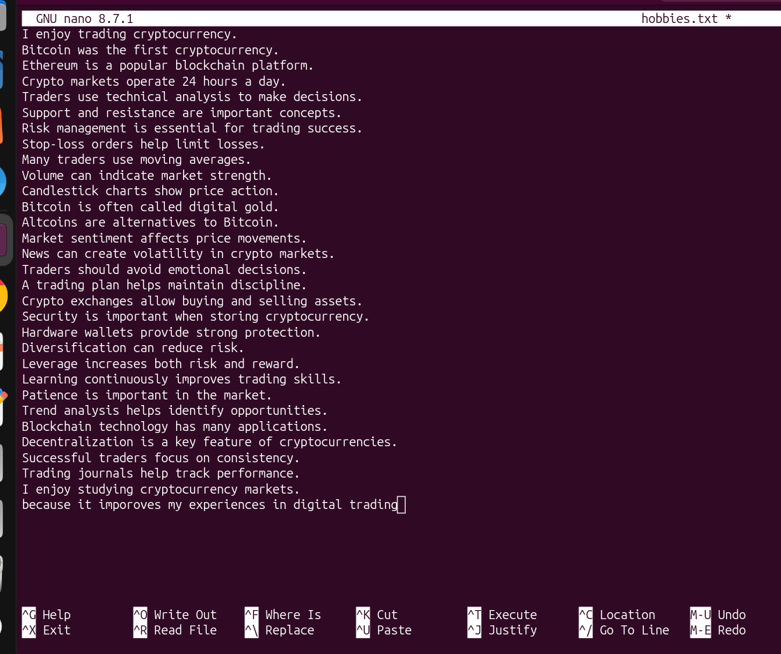
2 | We use head and tail command to display exactly the 5 first line of the file txt and 5 last 5 line of our txt file called hobbies | Yes | 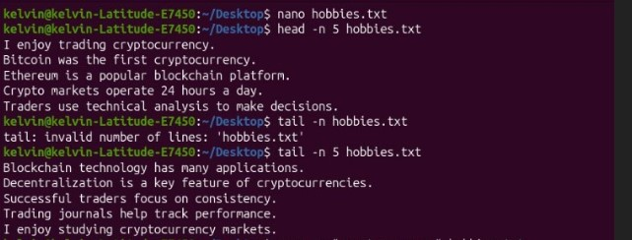
3 | We also use grep command to search for the selected word cryptocurrency and manage to display matching line with line numbes | Yes | 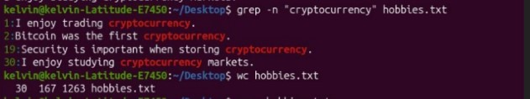
4 | By using command wc we manage to count word,line and character in your file txt hobbies | Yes
5 | We open the file hobbies in nano, edit and save it again. Finally we reopen it in cat to verfy changes | Yes | 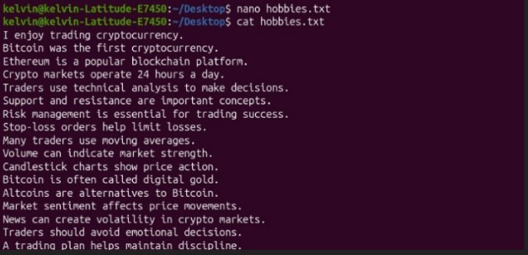

E. Command Evidence Log
Record the key commands your group ran. Attach screenshots after this page or include terminal output in an appendix.

# | Task Ref. | Command(s) Run / Description | Screenshot?
1 | Task 1 | (nano command we use it to create and text file called hobbies with 30 line distoratory)  Command:  $ nano hobbies.txt | 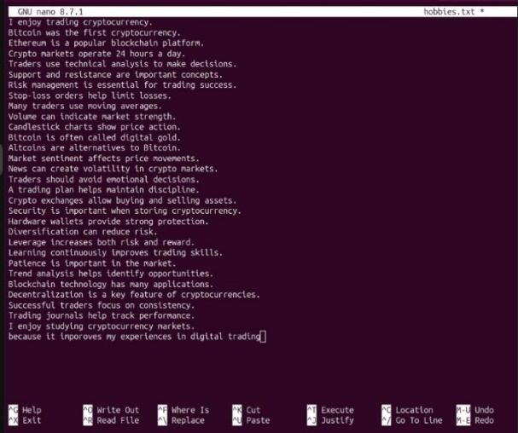
2 | Task 2 | ( we use command head and tail to show all line first and last line in our file txt hobbies)  Command:  $ head –n 5 hobbies.txt  $ tail –n 5 hobbies.txt | 
3 | Task 3 | (command grep used to show a specific word selected in our file txt hobbies)  Command:  $ grep –n “cryptocurrency” hobbies.txt | 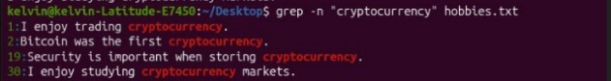
4 | Task 4 | (we use command wc to list all character,line and word present in our file txt hobbies)  Command:  wc hobbies.txt
5 | Task 5 | Command:  nano hobbies.txt  cat hobbies.txt  (we use nano to open file, edit and save again. We use cat to reopen again and verfy) | 

F. Creativity Challenge
Describe the real-world scenario your group chose and explain your creative design decisions.

Creativity Challenge
Scenario we chose:

Our creative approach:

G. Self-Exploration (Individual — one per member)
Each group member must complete their own copy of this section. Photocopy this page or attach separate sheets — one per member.

Student Name: ________________________________ Reg. No.: ___________________________

Self-Exploration Findings
Exploration question answered:

Key commands tested:

What I discovered:

H. Group Member Contributions
Briefly describe what each member contributed. The percentages must add up to 100% per task (or you can distribute overall contribution).

Member Name | Specific Contribution | % Contribution
FREDY RESPICHIUS MATUNGWA | Perforn Task 1 and wrote a report | 20%
KELVN EMANUEL SILIVESTA | Run and perform task 2 as well as take screenshots | 20%
GLORY PETER SALUM | Perform task 3 and outline | 20%
TEKLA JOHN MKUDE | Perform Task 4 | 20%
MARIA AGUSTINO KIKOTI | Run command for Task 5 | 20%
J. Declaration
We declare that this is our own group work. All commands were run on a real Linux system. All members participated as recorded above. We have not copied work from another group.

Group Leader Signature:

Date: ____________________________

EASTC | DSU07210 Linux Systems Administration | 2025/2026

